1. AIM:Write the python program for Vacuum Cleaner problem. ALGORITHM:
   1. Initialize: Define the environment (dirty and clean squares) and vacuum’s initial position.
   2. Generate Actions: Define possible actions (move, clean).
   3. Apply Actions: Simulate the result of actions on the environment.
   4. Check for Goal: Verify if all squares are clean.
   5. Plan Path: Use search algorithms (BFS, DFS) to determine the sequence of actions to clean all squares. PROGRAM:

import random

class VacuumCleaner:

def init (self, grid_size):

self.grid_size = grid_size

self.grid = [['dirty' if random.random() < 0.3 else 'clean' for _ in range(grid_size)] for _ in range(grid_size)]

self.x = random.randint(0, grid_size - 1) self.y = random.randint(0, grid_size - 1) self.cleaned_cells = 0

def print_grid(self):

for row in self.grid:

print(' '.join(row)) print()

def move(self, direction):

if direction == 'up' and self.x > 0:

self.x -= 1

elif direction == 'down' and self.x < self.grid_size - 1: self.x += 1

elif direction == 'left' and self.y > 0:

self.y -= 1

elif direction == 'right' and self.y < self.grid_size - 1: self.y += 1

def clean(self):

if self.grid[self.x][self.y] == 'dirty': self.grid[self.x][self.y] = 'clean' self.cleaned_cells += 1

def get_possible_moves(self):

moves = [] if self.x > 0:

moves.append('up')

if self.x < self.grid_size - 1: moves.append('down')

if self.y > 0:

moves.append('left')

if self.y < self.grid_size - 1: moves.append('right')

return moves def run(self):

while self.cleaned_cells < sum(row.count('dirty') for row in self.grid): self.clean()

possible_moves = self.get_possible_moves() if possible_moves:

self.move(random.choice(possible_moves))

def main():

grid_size = 5

vacuum = VacuumCleaner(grid_size) print("Initial Grid:") vacuum.print_grid()

vacuum.run() print("Final Grid:") vacuum.print_grid()

print(f"Total cleaned cells: {vacuum.cleaned_cells}") if name == " main ":

main()

# OUTPUT

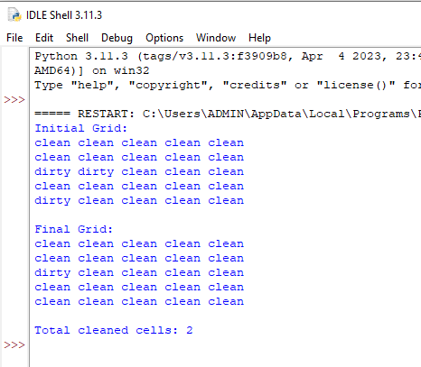

1. **AIM:**Breadth-First Search (BFS)

ALGORITHM:

1. Initialize: Start from the initial node and add it to a queue.
2. Explore Nodes: Dequeue a node and explore its neighbors.
3. Check for Goal: If a neighbor is the goal, return the path.
4. Queue Neighbors: Add unvisited neighbors to the queue.
5. Repeat: Continue until the queue is empty or the goal is found.

PROGRAM:

from collections import deque

def bfs(graph, start_node): visited = set()

queue = deque([start_node]) traversal_order = []

while queue:

node = queue.popleft() if node not in visited:

visited.add(node) traversal_order.append(node) for neighbor in graph[node]:

if neighbor not in visited: queue.append(neighbor)

return traversal_order def main():

graph = {

'A': ['B', 'C'],

'B': ['A', 'D', 'E'],

'C': ['A', 'F'],

'D': ['B'],

'E': ['B', 'F'],

'F': ['C', 'E']

}

start_node = 'A' print("Graph:")

for node, neighbors in graph.items(): print(f"{node}: {neighbors}")

print("\nBFS Traversal Order:") traversal_order = bfs(graph, start_node) print(traversal_order)

if name == " main ": main()

# output

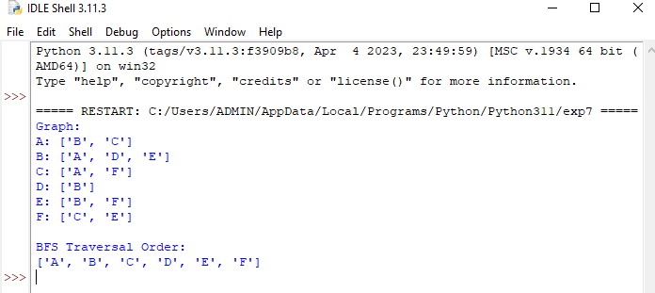

1. **AIM:**Depth-First Search (DFS)

ALGORITHM:

1. Initialize: Start from the initial node and add it to a stack.
2. Explore Nodes: Pop a node from the stack and explore its neighbors.
3. Check for Goal: If a neighbor is the goal, return the path.
4. Stack Neighbors: Add unvisited neighbors to the stack.
5. Repeat: Continue until the stack is empty or the goal is found.

PROGRAM:

def dfs_recursive(graph, node, visited=None):

if visited is None: visited = set() visited.add(node)

return [node] + [n for neighbor in graph[node] if neighbor not in visited for n in dfs_recursive(graph, neighbor, visited)]

def dfs_iterative(graph, start_node):

visited, stack, order = set(), [start_node], [] while stack:

node = stack.pop()

if node not in visited: visited.add(node) order.append(node) stack.extend(reversed(graph[node]))

return order def main():

graph = {

'A': ['B', 'C'],

'B': ['A', 'D', 'E'],

'C': ['A', 'F'],

'D': ['B'],

'E': ['B', 'F'],

'F': ['C', 'E']

}

start_node = 'A' print("Graph:")

for node, neighbors in graph.items(): print(f"{node}: {neighbors}")

print("\nDFS Traversal Order (Recursive):") print(dfs_recursive(graph, start_node)) print("\nDFS Traversal Order (Iterative):") print(dfs_iterative(graph, start_node))

if name == " main ": main()

# output

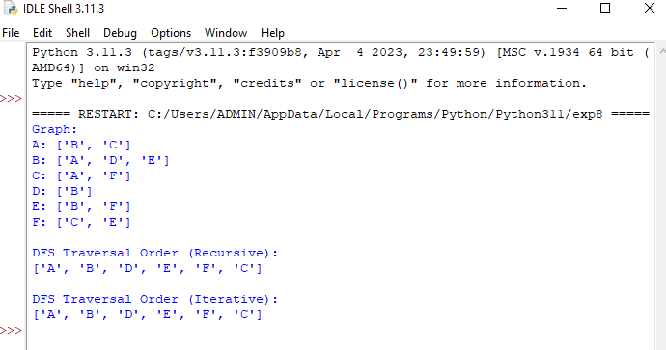

1. **AIM:**Travelling Salesman Problem (TSP)

ALGORITHM:

1. Initialize: Define cities and distances between them.
2. Generate Permutations: Create all possible routes. 3.Calculate Costs: Compute the total distance for each route.
3. Find Minimum: Identify the route with the minimum total distance.
4. Return Solution: Return the shortest route and its cost.

PROGRAM:

from itertools import permutations

def calculate_path_cost(distance_matrix, path): cost = 0

for i in range(len(path) - 1):

cost += distance_matrix[path[i]][path[i + 1]] cost += distance_matrix[path[-1]][path[0]] return cost

def tsp_bruteforce(distance_matrix):

n = len(distance_matrix) cities = list(range(n)) min_cost = float('inf') best_path = []

for perm in permutations(cities):

current_cost = calculate_path_cost(distance_matrix, perm) if current_cost < min_cost:

min_cost = current_cost best_path = perm

return min_cost, best_path def main():

distance_matrix = [ [0, 10, 15, 20],

[10, 0, 35, 25],

[15, 35, 0, 30],

[20, 25, 30, 0]

]

min_cost, best_path = tsp_bruteforce(distance_matrix) print("Optimal Path:", best_path)

print("Minimum Cost:", min_cost) if name == " main ":

main() OUTPUT:



1. **AIM:**A* Algorithm

ALGORITHM:

1. Initialize: Start from the initial state, define the goal, and create open and closed lists.
2. Generate Successors: Create possible moves from the current state.
3. Evaluate Cost: Compute the cost (g) and heuristic (h) for each successor.
4. Select Node: Choose the node with the lowest f = g + h from the open list.
5. Check for Goal: If the node is the goal, return the path.

PROGRAM:

import heapq

def heuristic(a, b):

return abs(a[0] - b[0]) + abs(a[1] - b[1]) def astar(grid, start, goal):

rows, cols = len(grid), len(grid[0])

open_set = [(0 + heuristic(start, goal), 0, start)]

came_from = {} cost_so_far = {start: 0} while open_set:

_, current_cost, current = heapq.heappop(open_set) if current == goal:

path = []

while current in came_from: path.append(current)

current = came_from[current] return path[::-1] + [goal]

for dx, dy in [(-1, 0), (1, 0), (0, -1), (0, 1)]:

neighbor = (current[0] + dx, current[1] + dy)

if 0 <= neighbor[0] < rows and 0 <= neighbor[1] < cols and grid[neighbor[0]][neighbor[1]] == 0: new_cost = current_cost + 1

if neighbor not in cost_so_far or new_cost < cost_so_far[neighbor]: cost_so_far[neighbor] = new_cost

priority = new_cost + heuristic(neighbor, goal) heapq.heappush(open_set, (priority, new_cost, neighbor)) came_from[neighbor] = current

return []

def print_grid(grid, path):

path_set = set(path)

for i, row in enumerate(grid): for j, cell in enumerate(row):

if (i, j) == path[0]: print('S', end=' ')

elif (i, j) == path[-1]: print('G', end=' ')

elif (i, j) in path_set: print('.', end=' ') else: print('#' if cell == 1 else ' ', end=' ')

print() def main():

grid = [

[0, 0, 0, 0, 0],

[0, 1, 1, 1, 0],

[0, 0, 0, 1, 0],

[0, 1, 0, 0, 0],

[0, 0, 0, 0, 0]

]

start, goal = (0, 0), (4, 4) path = astar(grid, start, goal) if path:

print("Path found:") print_grid(grid, path)

else:

print("No path found.") if name == " main ":

main()

**OUTPUT:**

